Burpham Church Fabric Report 2018

2018 saw a number of problems arise in both buildings but fortunately none of them major, although we still have the serious long term issues, identified in the Quinquennial (5 yearly) inspections carried out early in 2017, arising principally from the age of the buildings. We have also been considering further improvements to enhance our ministry, but substantial sums are involved, and plans are at a very early stage.

St Luke’s Church
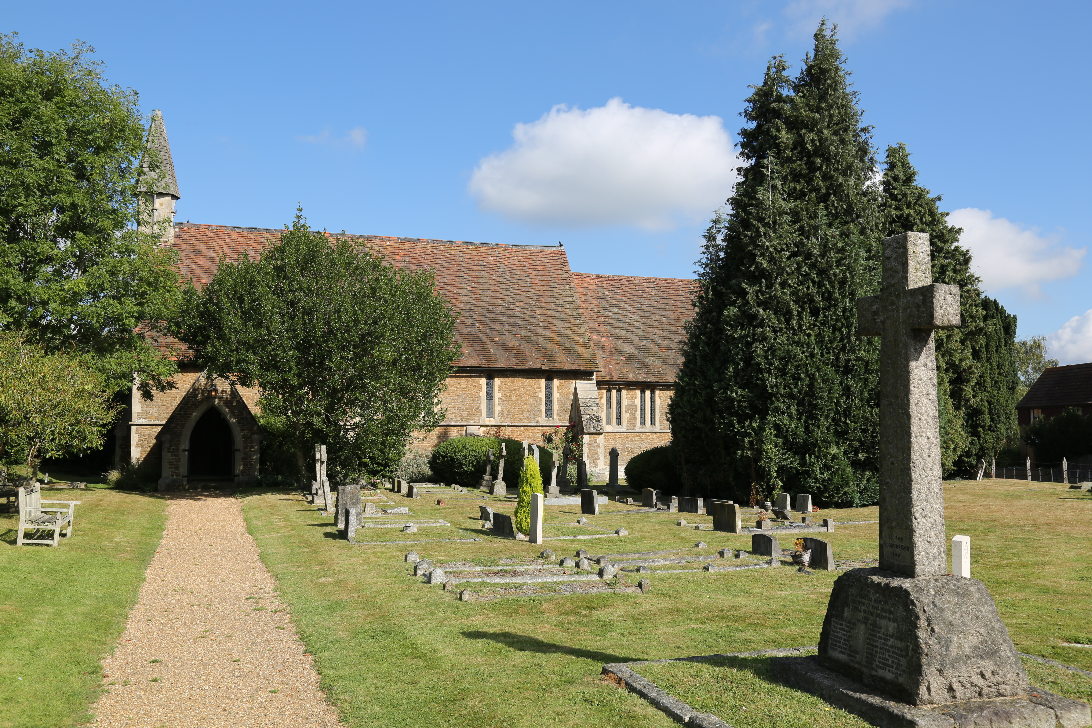
We continue to enjoy the new electrics and, in particular in winter months, the new heating put in at the end of 2016. This was again appreciated by many at the two Carol Services and the Midnight Communion service in December. Unfortunately at that service problems arose with the organ and we are still investigating whether it can be repaired economically. It would be difficult to justify major expenditure on the organ there given its relatively limited usage. Since December we have had problems with the gas supply pipe between the meter and the heaters, and have had to have it replaced.

The main issue at St Luke’s remains that identified again in the 2017 Quinquennial Inspection - the need to re-roof the whole church replacing the supporting battens. It has been previously reported that we have twice applied for a Roof Grant for this work but on both occasions were unsuccessful.
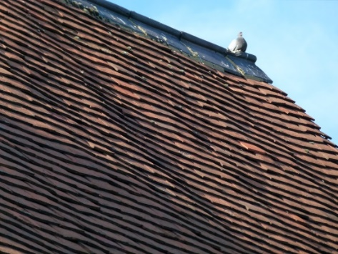
The undersized battens which are failing are the cause of the undulations which can be seen in the roof. The problem has existed for some time, and the rate of deterioration is difficult to assess. Work is also needed to the rainwater drainage system and the bellcote.

We have recently arranged for the gutters and downpipes to be cleaned and temporarily repaired to reduce deterioration of the fabric.
Church of the Holy Spirit

There have been a number of relatively minor issues at CHS.
These include replacing the mixer taps in the Belfast sink near the front entrance off the playground, repairing the emergency lighting, and mending the lighting control unit. We repaired the front toilet heaters, adding a control unit with timer. We also did a variety of minor repairs to the fabric after damage.  Externally we again patched the worst of the potholes in the car park and repainted the white lines for parking spaces. We also replaced a manhole cover damaged probably by a heavy vehicle. | 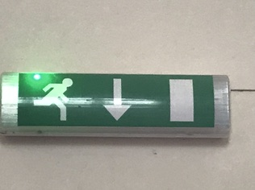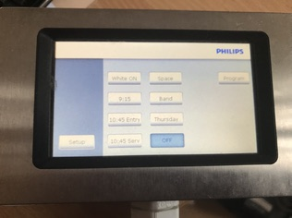  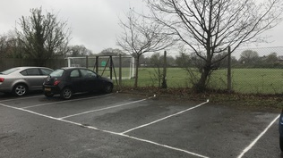

General condition

As previously reported the 2017 quinquennial inspection of CHS expressed serious concerns about the flat roofed area of building at the front of the site, which is the only part not to have seen major refurbishment in the last 10 years. Significant work is required to the walls, roof and windows ideally by replacement of that part of the building.  It has also become clear in the last year (although raised as a less significant issue in the quinquennial inspection) that the southern elevation of the church is deteriorating and needs repairs to both the fascia and the woodwork around the windows. We will also need to resurface the car park fully before too long. | 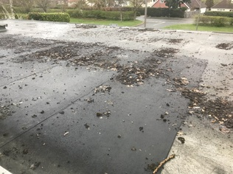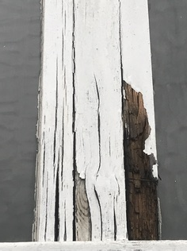  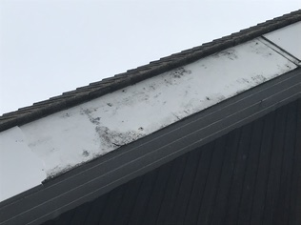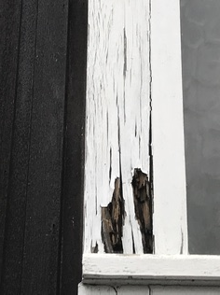
As reported above for St Luke’s we have recently also arranged for the gutters and downpipes to be cleaned at CHS and one area to be repaired to reduce deterioration of the fabric.
Planning for the future

As mentioned last year the PCC has been considering where our next investment should be, although given the sums likely to be involved it is unlikely this can be for some time. Much thought and prayer are going into this given the substantial funding that will be necessary. The wish of the PCC is that, while there are pressing needs at both St Luke’s and CHS to replace time expired fabric, that as far as possible we link this to, and focus on, enhancing our ministry.

Thank you

Once again we would like to thank the church family for their generosity both in time and financially. Funds related to our buildings have not only enabled a variety of works to improve our buildings, but also now paid off all the debts arising from the creation of the Barnabas Room and the previous work on the church, office and foyer. Much work has been done by volunteers particularly at CHS in the last year and we again wish to express our thanks to all involved.

